P530/2
BIOLOGY
(Theory)
Paper 2
July, 2018
2 ½ Hours

Uganda Advanced Certificate of Education
BIOLOGY
Paper 2
2 hours 30 minutes

INSTRUCTIONS TO CANDIDATES:
- This paper consists of six questions.
- Answer question one in section A plus three others from section B.
- Candidates are advised to read the questions carefully, organize their answers and present them precisely and logically, illustrating with well labeled diagrams wherever necessary.

SECTION A: (40 MARKS)
- 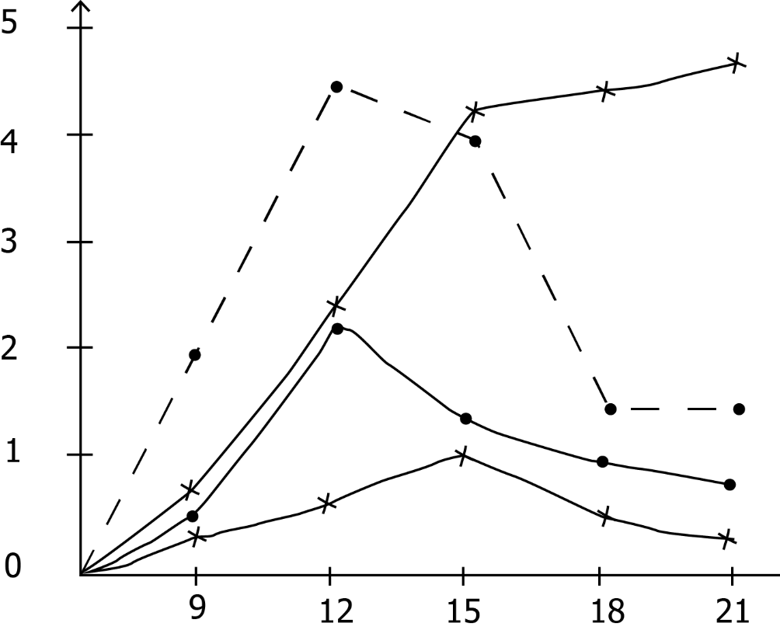The figure shows the changes in leaf area index (ratio of leaf surface to soil surface (m² cm⁻²) of two species of clover, Triforium repens and Triforium fragiferum, growing in a pure and mixed stand.
T. fragiferum(pure)
T. repens (mixed)
T. fragiferum(mixed)
Weeks after sowing
T. repens (pure)
Leaf area index

Table 1 shows the characteristics of the petioles and leaf size of the two species of clover.
 | Characteristic
 | T.fragiferum | T.repens
Petiole length | Long | Short
Leaf size | Large | Small
Use the information in the figure and table to answer the questions that follow.
- Compare the leaf area index of Trifolium repens and T.fragiferum in the;
- pure stands (06marks)
- mixed stands (06marks)
- Explain the trend in leaf area index for Trifolium repens in pure stands. (10marks)
- Explain the difference in growth rate of the two species in mixed stands. (07marks)
- Explain why Trifolium fragiferum continues to grow after the peak of Trifolium repens? (04marks)
- What conclusion can you draw from the results in a mixed stand. (04marks)
- What other factors are likely to have caused the difference in growth rate of the two species in mixed stand? (03marks)
SECTION B (60MARKS)
2 a) Describe how the loop of Henle operates as a counter-current multiplier. (08marks)
b) Explain how different animals have solved their osmotic challenges. (12marks)

3 a) How does variation in osmotic pressure in the soil surrounding the root hair cells affect mechanical support? (10marks)
b) Explain how plant hormones are transported. (10marks)

4 a) Describe how abnormal hemoglobin arises in the human population. (9 marks)
b) Explain:
- the effect of the gene for abnormal heamoglobin in the human population (07 marks)
- why people with the sickle cell trait do not suffer from malaria. (05 marks)

5 a) Describe the events that lead to perception of a clear image from a far object by humans during a bright day (10marks)
b) Discuss the significance of coordinating systems in animals. (10marks)

6 a) Compare the structure and functioning of the cardiac and skeletal muscles (10marks)
b) Explain how structural features of birds are related to flight (10marks)

END

